Name : I. Swetha Reg no: 192412374
Course code : ECA1301

CODE :
clc; clear; close all;

Course Name : Microwave Engineering Software using : Matlab

%% TEM, TE AND TM PROPAGATION MODE ANALYSIS

c = 3e8;

% Rectangular waveguide dimensions
a = 22.86e-3;
b = 10.16e-3;

% Coaxial line dimensions r1 = 0.5e-3;
r2 = 1.65e-3;

%% FIELD GRIDS

% Coaxial TEM field
x1 = linspace(-r2,r2,100); y1 = linspace(-r2,r2,100); [X1,Y1] = meshgrid(x1,y1);

R = sqrt(X1.^2 + Y1.^2); E_TEM = r1 ./ max(R,1e-12); E_TEM(R < r1 | R > r2) = NaN;

% Rectangular waveguide grid x = linspace(0,a,100);
y = linspace(0,b,80); [X,Y] = meshgrid(x,y);

% TE10 electric and approximate magnetic field patterns E_TE10 = sin(pi*X/a);
H_TE10 = cos(pi*X/a);

% TM11 electric and illustrative magnetic field patterns E_TM11 = sin(pi*X/a).*sin(pi*Y/b);
H_TM11 = cos(pi*X/a).*cos(pi*Y/b);

%% CUTOFF FREQUENCIES

fc_TE10 = c/(2*a); fc_TE20 = c/a;
fc_TM11 = (c/2)*sqrt((1/a)^2 + (1/b)^2);

fprintf('CUTOFF FREQUENCIES\n');
fprintf('TE10 = %.3f GHz\n',fc_TE10/1e9); fprintf('TE20 = %.3f GHz\n',fc_TE20/1e9); fprintf('TM11 = %.3f GHz\n',fc_TM11/1e9);

%% PROPAGATION CONSTANTS

f = linspace(1e9,30e9,600);

beta_TE10 = zeros(size(f)); beta_TE20 = zeros(size(f)); beta_TM11 = zeros(size(f));

idx = f > fc_TE10;
beta_TE10(idx) = (2*pi*f(idx)/c).* ... sqrt(1-(fc_TE10./f(idx)).^2);

idx = f > fc_TE20;
beta_TE20(idx) = (2*pi*f(idx)/c).* ... sqrt(1-(fc_TE20./f(idx)).^2);

idx = f > fc_TM11;
beta_TM11(idx) = (2*pi*f(idx)/c).* ... sqrt(1-(fc_TM11./f(idx)).^2);

%% CREATE ONE FIGURE WITH SIX GRAPHS

figure('Name','TEM TE TM Analysis - Six Graphs', ... 'NumberTitle','off', ...
'Position',[50 50 1400 900]);

%% GRAPH 1: TEM FIELD - 3D SURFACE

subplot(3,2,1);

surf(X1*1000,Y1*1000,E_TEM,'EdgeColor','none'); xlabel('x (mm)');

ylabel('y (mm)'); zlabel('|E| (normalized)');
title('Graph 1: TEM Electric Field'); colorbar;
view(45,35); grid on;
axis tight;

%% GRAPH 2: TE10 ELECTRIC FIELD - 3D SURFACE

subplot(3,2,2);

surf(X*1000,Y*1000,E_TE10,'EdgeColor','none'); xlabel('x (mm)');
ylabel('y (mm)'); zlabel('E (normalized)');
title('Graph 2: TE10 Electric Field'); colorbar;
view(35,30); grid on;
axis tight;

%% GRAPH 3: TM11 ELECTRIC FIELD - 3D SURFACE

subplot(3,2,3);

surf(X*1000,Y*1000,E_TM11,'EdgeColor','none'); xlabel('x (mm)');
ylabel('y (mm)'); zlabel('E (normalized)');

title('Graph 3: TM11 Electric Field'); colorbar;
view(55,40); grid on;
axis tight;

%% GRAPH 4: TE10 MAGNETIC FIELD PATTERN

subplot(3,2,4);

surf(X*1000,Y*1000,H_TE10,'EdgeColor','none'); xlabel('x (mm)');
ylabel('y (mm)'); zlabel('H (normalized)');
title('Graph 4: TE10 Magnetic Field Pattern'); colorbar;
view(45,35); grid on;
axis tight;

%% GRAPH 5: CUTOFF FREQUENCY COMPARISON

subplot(3,2,5);

fc = [fc_TE10 fc_TE20 fc_TM11]/1e9; bar(fc);
set(gca,'XTick',1:3); set(gca,'XTickLabel',{'TE10','TE20','TM11'});
ylabel('Cutoff Frequency (GHz)'); title('Graph 5: Cutoff Frequencies');

grid on;

%% GRAPH 6: PROPAGATION CONSTANT COMPARISON

subplot(3,2,6);

plot(f/1e9,beta_TE10,'b','LineWidth',2); hold on;
plot(f/1e9,beta_TE20,'r--','LineWidth',2);
plot(f/1e9,beta_TM11,'k-.','LineWidth',2);

xlabel('Frequency (GHz)'); ylabel('\beta (rad/m)');
title('Graph 6: Propagation Constants'); legend('TE10','TE20','TM11','Location','northwest'); grid on;

sgtitle('Simulation-Based Electromagnetic Analysis of TEM, TE and TM Modes');

fprintf('\nAll six graphs generated successfully.\n');

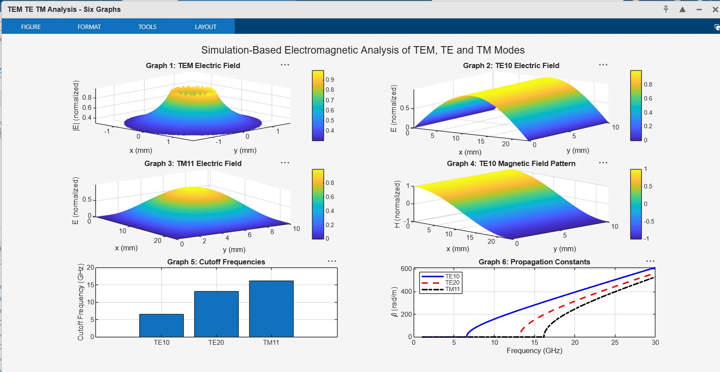
output :

